SOFTWARE ENGIINEERING - CSA1086

Collaborating on GitHub

* Forking a Repository

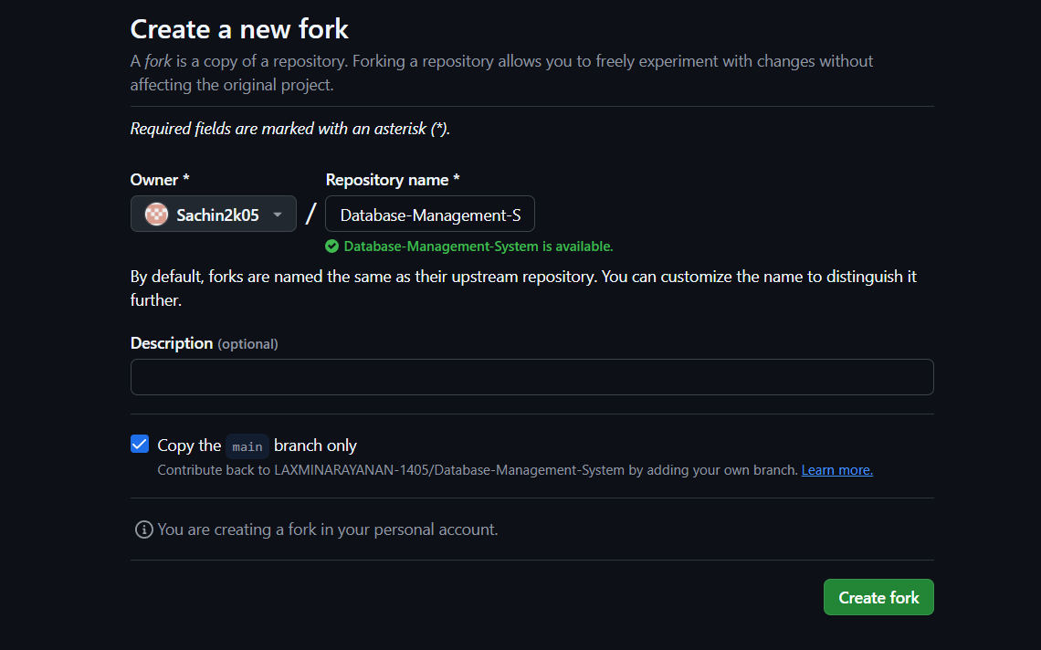

* Cloning the Forked Repository

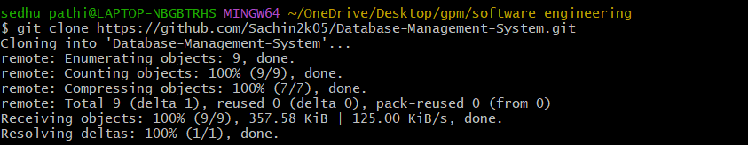

* Move into the cloned repo folder



* Creating a New Branch



* Implementing Changes

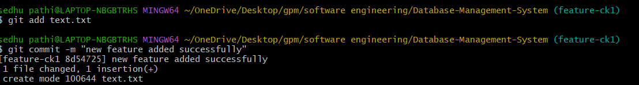

* Pushing Changes to the Forked Repository

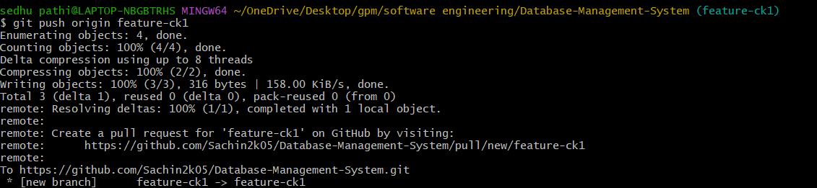

* Submitting a Pull Request

